|  |  |  |  |  |  |
| --- | --- | --- | --- | --- | --- |
| 安全风险  等级 |  |  | 实验室名称 |  | 楼宇名 |
| 卫法楼 |
| 卫生部法医学重点实验室 | 房间号 |
| 危险源分类 |  |  |  | 931 |

|  |  |  |  |  |  |
| --- | --- | --- | --- | --- | --- |
| 危险类别 |  | 防护措施 | |  | 灭火要点 |
|  |  |  |  |  |  |
|  |  |  |  |  |  |
|  |  |  |  |  |  |
|  |  |  |  |  |  |
|  |  |  |  |  |  |

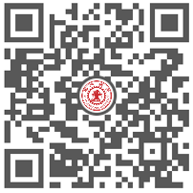

|  |  |  |  |  |  |  |
| --- | --- | --- | --- | --- | --- | --- |
| 所属院系 | XX学院 |  | 紧急联系人 | XXX |  | 报警电话 |
| 责任人 | XXX |  | 联系电话 | 130XXXXXXXX |  | 82655110 |